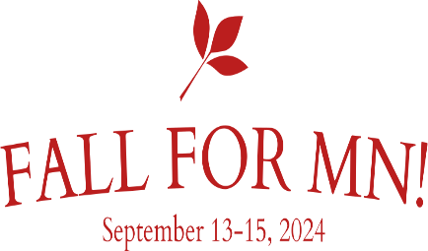
NCS 2024 FALL SECTION MEETING REGISTRATION
Hosted by the Minnesota Chapter – September 13-15, 2024
Name: _______________________________________________________________
Guest: ________________________________________________________________
Chapter: ______________________________________________________________
Email:________________________________________Phone: ___________________

Cambria Hotel, 8001 Winstead Way, Bloomington, MN 55425, 612-235-6538
Book a hotel room using the link below – no later than August 15th for the group rate.
Reserve online at https://www.choicehotels.com/reservations/groups/dm17l2.
Group Name: MN 99s. Group Number: DM17L2. Complimentary self-parking is available.
The room rate is $129/night + fees; double queens or single king rooms (limited number) are available.
If you have any registration questions, contact Tracy Davenport at tdavenport99@aim.com.
CHECK ALL THAT APPLY:
First-time attendee _____ |  | New 99 (less than 1 yr.) _____ |  |  | Student pilot _____
AE Scholarship recipient _______ Year: _______ |  |  | FIRST WINGS Award recipient _______ Year: _______
Please list | Current Office(s)/Committee(s): |  |  | Past Office(s)/Committee(s):
Chapter:
Section:
International:
ARRIVALS: Needing transportation to hotel. Note: The Cambria Hotel has an airport shuttle to/from MSP (612-235-6538).
Comm.: KMSP |  | Arr Date: ______ |  | ETA ______ |  | Airline __________ |  | Flight # _______ | # PAX _____ | Dept. Date/Time: __________
GA: KFCM | Arr Date: ______ |  | ETA ______ |  | FBO/Ramp __________ |  | A/C N No. _______ |  | # PAX _____ | Dept. Date/Time: __________

REGISTRATION |  | Cost | Quantity | Total
99, Friend, guest, and/or 49 ½ (no later than August 15, 2024) |  | $139.00
LATE Registration (August 16th, 2024, or later) |  | $149.00
FULL registration includes a check-in packet, access to the Hospitality Room and Fly-Market, Saturday breakfast and lunch, Saturday MSP tours, and the Banquet.
Please list any Special Dietary Restrictions or Requests here for all provided meals:

A LA CARTE SELECTIONS |  |  |  |  | Cost | Quantity |  | Total
Fly-Market Sales table (99s chapter/member - $10, Guest vendor - $25) |  |  |  |  | $10 or $25
Friday – Padelford Riverboat Sunset Dinner Cruise |  |  |  |  | $57.22
Saturday – MSP Tours* - Please choose one of the options below:
- Behind-the-scenes MSP Terminal Facilities (Limit 20 people) |  |  |  | - Airfield Facilities Tour
*Important – A copy of a government-issued ID is required for the MSP tours. Please submit with registration.
 |  |  | GRAND TOTAL
Payment by (choose one): | - Check | - Zelle to Patti Sandusky 612-308-4291
REGISTRATION Deadline: Email or postmarked no later than August 23rd, 2024.
Email registration to tdavenport99@aim.com and pay electronically via Zelle (Patti Sandusky at 612-308-4291)
Mail the check and form to Tracy Davenport, 12119 Kentucky Circle, Champlin, MN 55316. Checks payable to Minnesota 99s.

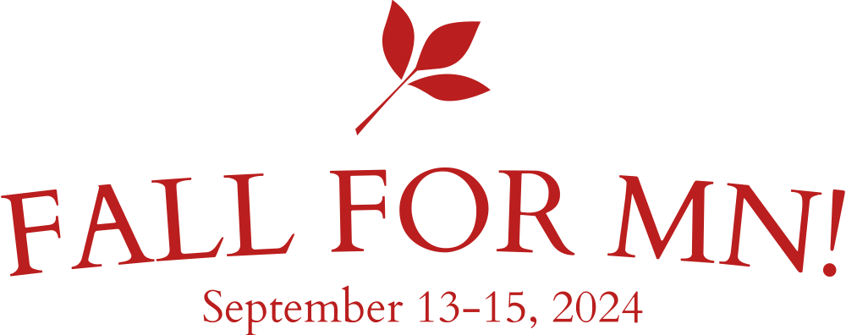
NCS Fall Meeting
Hosted by Minnesota Chapter
September 13 – 15, 2024
Cambria Hotel
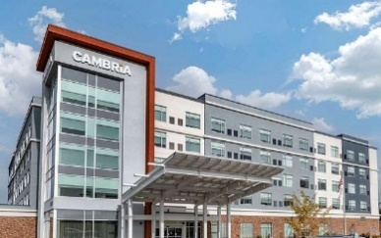
Bloomington, Minnesota

Schedule

Thursday, September 12, 2024 - Early arrivals: dinner on your own (hotel or nearby restaurant)
Friday, September 13, 2024
10:00 am – 4:00 pm | Registration
12:00 pm – 3:00 pm | Balloon Demonstration (Tentative)
1:00 pm – 4:00 pm | Hospitality Room/Fly Market Open
3:00 pm – 4:30 pm | Board Meeting
4:45 pm | Transportation to Padelford Sunset Dinner Cruise
5:30 pm – 8:00 pm | Padelford Sunset Dinner Cruise
9:00 pm – 11:00 pm | Hospitality Room Open
Saturday, September 14, 2024
7:00 am – 8:30 am | Breakfast and Chapter Chair/Treasurer Breakfast meeting
7:30 am – 8:45 am | Registration
8:45 am – 9:00 am | Sign-in for Business Meeting
9:00 am – 12:00 pm | Business Meeting
9:15 am – 11:15 am | 49 ½ Activity – Tour NW Airlines History Museum (back by 11:30 am)
12:30 pm | Depart for Behind-the-Scenes Tours of MSP
1:00 pm – 1:30 pm | Lunch at MSP Operations Building
1:30 – 4:30 pm | Behind-the-scenes Tours of MSP (Select one tour option on the registration form)
6:00 – 7:00 pm | Social Hour
7:00 – 9:00 pm | Banquet
9:00 pm – 11:00 pm | Hospitality Room Open
Sunday, September 15, 2024
7:00 am – 10:00 am | Departures for Airport(s)

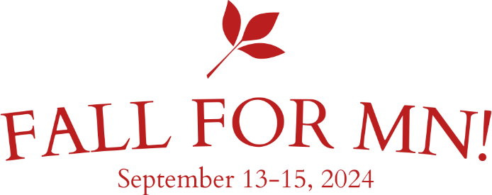
NCS Fall Meeting
Hosted by Minnesota Chapter
September 13 – 15, 2024

Activities

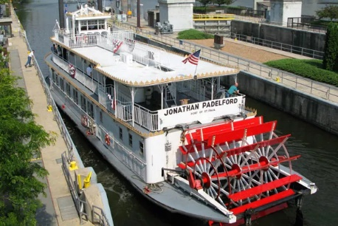
Padelford Sunset Dinner Cruise – Friday Evening
Imagine cruising along the Mississippi River in a magnificent riverboat, taking in the beautiful scenery and gentle breeze and watching the sun set across the Minnesota sky. In addition to the stunning views, enjoy a fabulous dinner of delicious barbecue (vegetarian and vegan options available with advanced notice). Experience an evening everyone will remember. Come aboard!

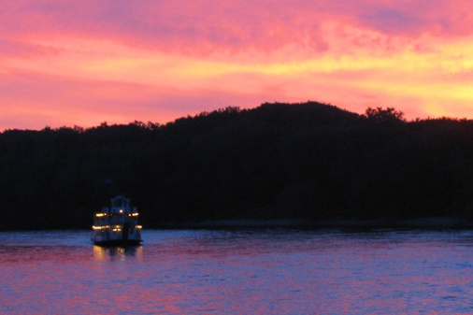
Dinner Menu
Classic BBQ ribs with a secret recipe dry rub
House-brined and grilled chicken with house-made BBQ sauce
Cheddar green chili cornbread
Donna’s calico baked beans with brown sugar
Potato salad
Chef’s choice dessert and coffee

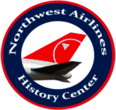
NW Airlines History Center (NWAHC) – Saturday Morning
Immerse yourself in 84 years of history at the Northwest Airlines History Center. The goal of the History Center is to tell the personal and global stories of how airlines connected the world. Examining and celebrating the impact of commercial aviation and the legacy of Northwest Airlines and its family tree. The NWAHC is located on the third floor of the Crowne Plaza Aire Hotel at 3 Appletree Square, Bloomington, MN. Admission is FREE, but donations can be made directly to the museum. (https://northwestairlineshistory.org/)

NCS Fall Meeting
Hosted by Minnesota Chapter
September 13 – 15, 2024

Activities

Behind the Scenes Tours of MSP Airport – Saturday Afternoon
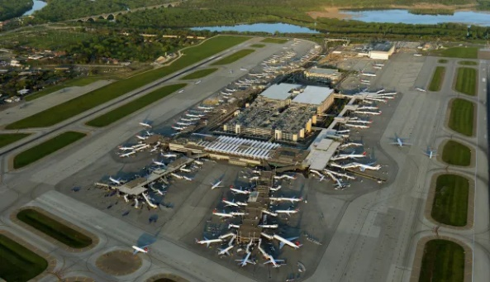
Look behind the curtain at Minneapolis-St. Paul International Airport (MSP). Conference attendees are invited to experience one of the following tour options:
Option 1: Behind-The-Scenes MSP Terminal Facilities—Venture through MSP’s award-winning terminal areas, baggage routing systems, travel confidently education center, and more! This tour is limited to the first 20 attendees and involves long stretches of extended walking (wheelchair accessible). This tour is not recommended for anyone with walking restrictions.
Option 2: Airfield Facilities Tour – This tour features an opportunity to explore MSP’s restricted access airfield areas and equipment staging areas. Attendees will take a bus ride journey through the airfield and learn about the award-winning facilities management equipment featuring the world-famous “Hegge.” This tour involves limited stretches of walking (wheelchair accessible), but attendees will have the option to climb aboard the maintenance equipment if desired. This tour is limited to 50 attendees.
Due to security requirements, attendees must submit a copy of their government-issued ID by August 15, 2024 (no exceptions). Please plan to submit a photo of your ID with the registration form.
Lunch: A box lunch will be provided before the MSP Tours. Please indicate any dietary restrictions on the registration form.
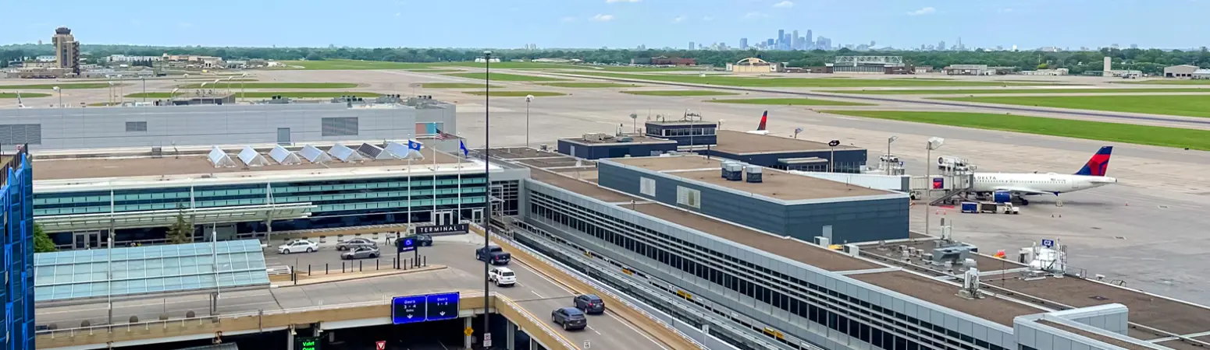
NCS Fall Meeting
Hosted by Minnesota Chapter
September 13 – 15, 2024

Saturday Night Banquet
The Banquet will be held in the Cambria Hotel Banquet Room. Social hour begins at 6:00 p.m., and the banquet starts at 7:00 p.m. Dinner will be an Italian Buffet. Please list any dietary requirements or restrictions on the registration form.
Vivo Italiano Buffet Menu
Minestrone Soup
Crisp Ceasar Salad
Seasonally Inspired Composed Salad
Chef’s Choice Vegetable
Herb Roasted Potatoes
Bouquet of Marinated & Grilled Vegetables
Cheesy Garlic Breadsticks with Marinara Dipping Sauce
Parmesan Crusted, Boneless Chicken Breast
Baked Rigatoni
Grilled Salmon Puttanesca
Tiramisu

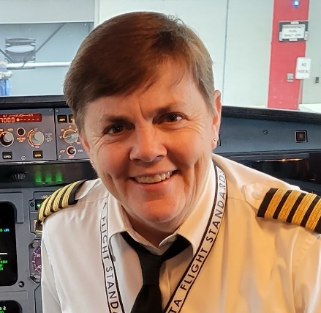
Guest Speaker – Captain Martha Whiteaker
Captain Martha Whiteaker currently flies for Delta Air Lines and serves as a check pilot to ensure flight proficiency. Her “unexpected” career began more than 33 years ago, and she has logged thousands of hours in a variety of airline and military aircraft. She is an influential aviator who helped pave a path for women pilots in the airline industry and the U.S. Navy. Martha also stars in an award-winning Meet the Fleet video that highlights features of the Airbus A350 aircraft. A fun fact about Martha is that she has never flown a general aviation aircraft, but that is her next adventure!

