Gateway to Flight
April 22-24, 2022
St. Louis, Missouri
Hosted by Greater St. Louis Chapter
HOTEL
LATE CHANGE – Our original meeting hotel (Holiday Inn Airport West) has canceled due to unforeseen circumstances. Those with reservations need not do anything – your reservations will be canceled. Our NEW venue is the Mercy Conference and Retreat Center (2039 North Geyer Rd, St. Louis MO 63131).
GOOD news - the per person room rate is $59.50/night (singles) or $41.25/night (doubles). This includes room and private bath. There are no taxes or fees. The Mercy Center only does one bill (not individual bookings), so the money for guest rooms must be paid to the Chapter, NOT to the Conference Center. Room payment will be collected at the Meeting Registration desk on-site.
AIRPORTS
GENERAL AVIATION / FBO
Spirit of St. Louis Airport (KSUS) – TAC Air (phone 636-532-8882) is located in the main terminal and is on the “white” ramp. Tie-downs are free with fuel purchase. We recommend use of TAC Air’s self-service fueling, just west of the main ramp, on the “yellow” ramp. Self-service fueling currently saves about $2.25/gal. TAC Air can arrange for Hertz car rental on the field. Budget car rental is also on the field, phone 636-532-0234.
https://www.thearnoldcos.com/tac-air/sus
Creve Coeur Airport (1H0) – Make arrangements for tie-downs or shade port (if available) directly with the FBO (phone 314-878-9575). Rental cars are not available at Creve Coeur Airport.
http://www.crevecoeurairport.com/
COMMERCIAL AVIATION
St. Louis Lambert International Airport (STL) - https://www.flystl.com/
TRANSPORTATION
For attendees arriving at Spirit of St. Louis or Creve Coeur Airport, Greater St. Louis 99s will provide transportation to/from the hotel. Contact information will be announced.
For attendees arriving at St. Louis Lambert International, the Holiday Inn Airport West (Earth City) offers free shuttle service to/from STL. For shuttle service, call Holiday Inn Airport West at 314-291-6800.
Addition Information / Contacts
Libby Yunger Phone: 314-920-7449 Email: libbygirlpilot@gmail.com
Nelda Lee Phone: 636-391-6882 Email: neldaklee@outlook.com
Martha Norman Phone: 573-546-7472 Email: cfifly170s@gmail.com
Gateway to Flight
99s North Central Section Spring Meeting
April 22-24, 2022
Hosted by Greater St. Louis Chapter
MEETING REGISTRATION
Name |  | Guest / 49½
Street |  | Phone
City/State/Zip |  | Chapter
Email
Check all that apply:
 | AE Scholarship Awardee |  | Governor |  | International Representative *
 | New 99 (less than 1 yr) |  | Past Governor |  | President
 | First Wings Awardee |  | NCS Officer * |  | Past President
 | Student Pilot |  | NCS Committee Chair * |  | International Committee Chair *
 | First Section Meeting |  | Chapter Officer *
* Specify:

FULL registration (99/Guest): _____ @ $ 99.00 each ______
Due to the venue change, attendees must complete an on-line survey to provide any dietary restrictions:
https://tz52745blke.typeform.com/to/okhIzhoS
(This link also collects other general info about your attendance to help in organizing events/transportation.)

(Includes: Sat Lunch, Sat Banquet, Hospitality Rm, Prologue Room Tour)
LATE Registration (after Apr 1) _____ @ $ 119.00 each _____
A LA CARTE:
Saturday Lunch ___ @ $ 35.00 each ______
Saturday Banquet ___ @ $ 45.00 each ______
Hospitality Room ___ @ $ 25.00 each ______
James S. McDonnell
Prologue Room _ ___ @ $ 15.00 each ______
Saturday Tour(s):
Registration Deadline: April 15
Write check to “Greater St. Louis Chapter 99s”
Mail check and registration to:
Martha Norman
160 Cedar Lane, Ironton, MO 63650
For questions, contact:
Libby Yunger Phone: 314-725-0428
Email: libbygirlpilot@gmail.com
Nelda Lee Phone: 636-391-6882
Email: neldaklee@outlook.com
Martha Norman Phone: 573-546-7472
Email: cfifly170s@gmail.com
Historic Aircraft Restoration Museum ____ @ $20.00 ea ______
Sales Table: ____ @ $ 10.00 ea ______
TOTAL: ______
ARRIVALS: Date _________ ETA _________
Number persons on board: _____ N number: _________
GA Arrival Airport (check one):
___ Spirit of St Louis (KSUS) ___ Creve Coeur (1H0)
Need transportation from GA airport? ___ Y ___ N
Commercial Arrivals – St. Louis Lambert International (STL)
Airline: ` Flight #:
Will you have a car? Y / N Can you help drive / share rides? Y / N

Gateway to Flight
99s North Central Section Spring Meeting
April 22-24, 2022
St. Louis, Missouri
Hosted by Greater St. Louis Chapter

MEETING SCHEDULE
Friday, April 22, 2022
Noon – 5:00 pm Registration
Set up Hospitality Room and Fly Market
2:00 – 4:00 pm Boeing’s James S. McDonnell Prologue Room Tour (10 mi)
4:30 – 5:30 pm Communication Session
5:00 – 7:00 pm Dinner
5:30 – 6:30 pm Board Meeting
7:00 – 9:00 pm FAA Safety Seminar – Crew Resource Management for GA
7:30 – 10:00 pm Social (beer/wine/refreshments)

Saturday, April 23, 2022
7:00 – 9:00 am Registration
Breakfast
8:30 – 11:00 am Wings of Hope tour (18 mi)
9:00 – 11:00 am NCS Business Meeting
11:30 am – 1:00 pm Lunch and Awards Presentation
1:30 – 5:00 pm Historic Aircraft Restoration Museum Tour (7 mi)
1:00 – 6:00 pm Hospitality Room and Fly Market
7:00 – 9:00 pm North Central Section Meeting Banquet
Speaker: Lt. Col. Caroline “Blaze” Jensen, USAF, Ret.

Sunday, April 24, 2022
7:00 – 9:00 am Breakfast
Departures

* * * Schedule Subject to Change * * *

Gateway to Flight
April 22-24, 2022
St. Louis, Missouri
Hosted by Greater St. Louis Chapter
WEEKEND ACTIVITIES
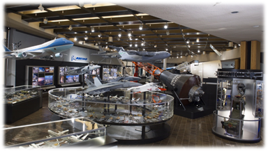
James S. McDonnell Prologue Room at Boeing
(Friday, 2:00-4:00 pm)
Boeing will open the James S. McDonnell Prologue Room from 2:00-4:00 p.m. on Friday, April 22, 2022, for the Ninety-Nines and their guests who arrive early for the 2022 North Central Section Spring Meeting.
The James S. McDonnell Prologue Room is a corporate museum that tells a panoramic story of more than a century of aviation progress. From biplanes to space travel, the exhibit showcases courageous pioneers of aviation and the achievements of thousands who turned dreams into reality. Visitors will view numerous historical model airplanes as well as large scale models of some of today’s military aircraft, including the Eagle, Hornet, Apache and Air Force One along with unmanned vehicles, rockets, missiles and commercial jetliners. Also on display are actual size Mercury and Gemini spacecraft and scale models of the Space Shuttle, Skylab and International Space Station.

Wings of Hope Tour (Saturday, 8:30-11:00 am)
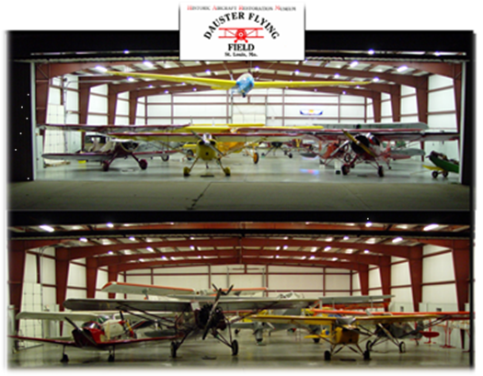
Wings of Hope, a humanitarian nonprofit organization, is headquartered at St. Louis’ Spirit of St. Louis Airport. There, aircraft are made ready for a new life of helping change and save lives through the power of aviation. Wings of Hope has been helping the world’s most vulnerable communities since 1962. Their hstory, however, traces back to 1959. They work to connect people to resources they need to reach their developmental goals thus changing the course of humanity toward peace and hope. They have operations in the US, Belize, Cambodia, Ecuador, Columbia, Nicaragua, Paraguay, Papua New Guinea, Tanzania, and Zambia. In the US, they operate within a radius of 900 miles of St. Louis – 30 states. Also in St. Louis, they have a STEM learning program centered on aviation and the workings of a global aviation nonprofit. They were nominated for the Nobel Prize in 2011 and 2012. Wings of Hope is powered by volunteers and is nonpolitical and nonsectarian.

Historic Aircraft Restoration Museum
(Saturday, 1:30-5:00 pm)
On Saturday our group will tour the Historic Aircraft Restoration Museum at Creve Coeur Airport.
The primary goal of the Museum is the acquisition, restoration, display and operation of antique and vintage aircraft. The Museum primarily focuses on, but is not limited to, aircraft and related items from “The Golden Age of Flight,” roughly 1920 to 1939, with particular interest in airplanes that were built in our area or have some type of local or regional historical significance. The Museum’s collection is housed in four main display hangars that currently hold a total of 49 aircraft – however the inventory of display aircraft changes when plane restorations are completed or when new additions to the collection are acquired.

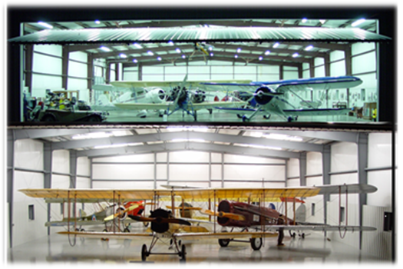
Lt. Col. Caroline “Blaze” Jensen, USAF, Ret. (Saturday Banquet Speaker)
Our speaker Saturday evening will be Caroline “Blaze” Jensen. Blaze is a 1998 graduate of the USAF Academy and a retired fighter pilot and veteran. She is a highly experienced command pilot, Instructor pilot and evaluator. During her time in the Air Force, she accumulated over 3500 hours in Schweizer 2-33 gliders, Cessna 172, T-37B Tweet, T-38 Talon and the F-16 Fighting Falcon. She was the first female reserve officer to fly for the US Air Force Air Demonstration Squadron (Thunderbirds) and is the first and only woman qualified to fly in the Air Force’s new jet trainer, the T-7A Red Hawk. Blaze has worked extensively with multiple media platform communications and team leadership.
Her flight experience includes 1870 hours in F-16 (200 hours combat, 610 hours as instructor), with a concentration on Close Air Support and aggressor mission, and 1500 hours in T-38 Talon. She remembers fondly flying in the #3 right wing position for the Thunderbirds, and also her time in Operation Iraqi Freedom supporting the US troops and our allies on the ground. Her Air Force adventure also took her through an assignment as a Legislative Fellow in the Secretary of the Air Force Legislative Liaison Senate office and later for a member of Senate Armed Service Committee. She is honored to be a board member at the National WWII WASP Museum at Avenger Field in Sweetwater, Texas.
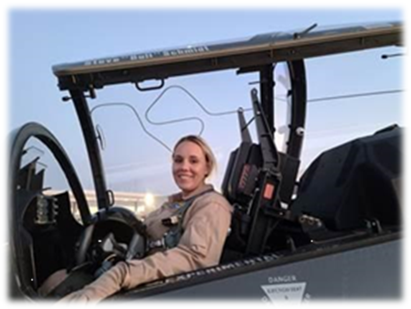
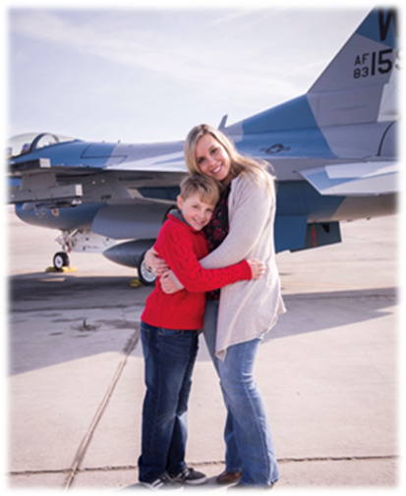
Blaze is a single mother to her one son, Finn, who is also in love with aviation and had the distinction of being the first kid in the US (maybe the world) to see his mother fly in an advanced jet aerobatic demonstration. She resides with Finn and their dog Yogi in
River Falls, Wisconsin.

